# **Practical – 5**

**Aim: Write a program to implement Linear Regression**

* Code:

from os import XATTR_SIZE_MAX

import numpy as np

import matplotlib.pyplot as plt

import pandas as pd

from sklearn.model_selection import train_test_split

from sklearn.linear_model import LinearRegression

import seaborn as sns

data_set = pd.read_csv('/content/drive/MyDrive/temp/practical_4_2.csv')

print(data_set)

X = data_set[['Match_Duration', 'Loot_Collected', 'Enemies_Defeated']]

y = data_set['Player_Score']

print(X, y)

X_train, X_test, y_train, y_test = train_test_split(X, y, test_size=0.2, random_state=42)

print(X_train, X_test, y_train, y_test)

model = LinearRegression()

model.fit(X_train, y_train)

y_pred = model.predict(X_test)

plt.figure(figsize=(10, 6))

sns.scatterplot(x=y_train, y=model.predict(X_train), color='blue', label='Training Data')

plt.xlabel('Actual Player Score')

plt.ylabel('Predicted Player Score')

plt.title('Training Data: Actual vs Predicted Player Score')

plt.legend()

plt.show()

plt.figure(figsize=(10, 6))

sns.scatterplot(x=y_test, y=y_pred, color='orange', label='Test Data Predictions')

plt.xlabel('Actual Player Score')

plt.ylabel('Predicted Player Score')

plt.title('Test Data: Actual vs Predicted Player Score')

plt.legend()

plt.show()

* 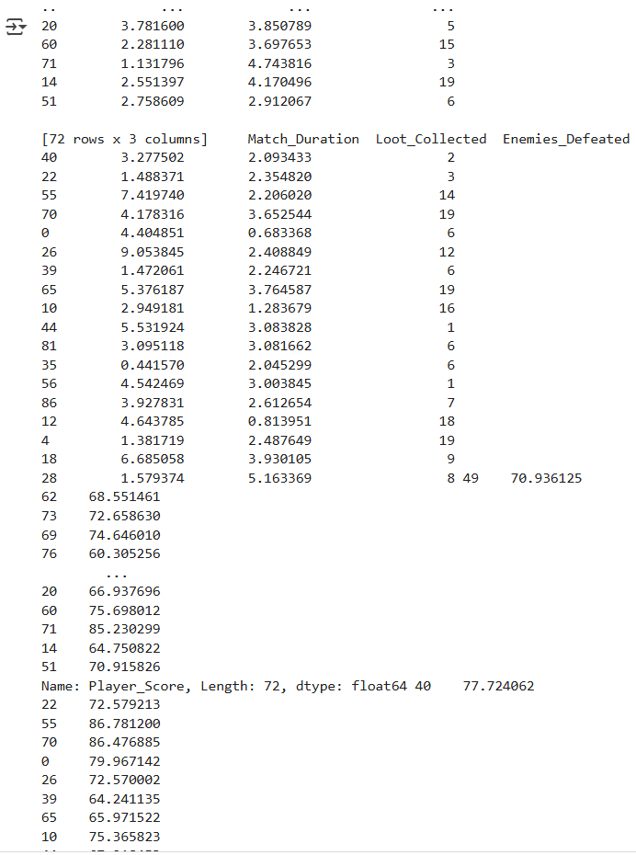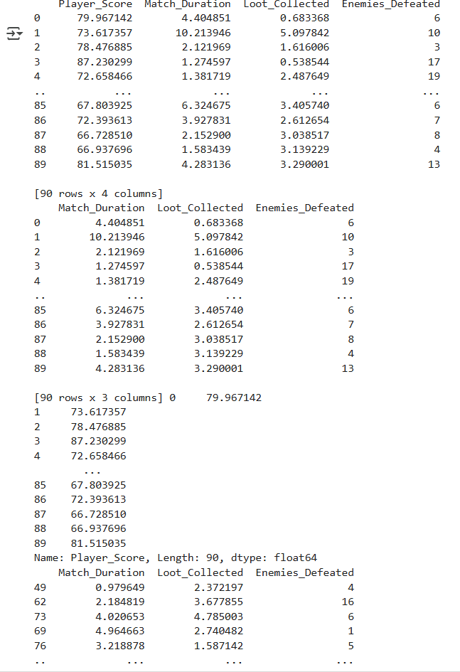Output:

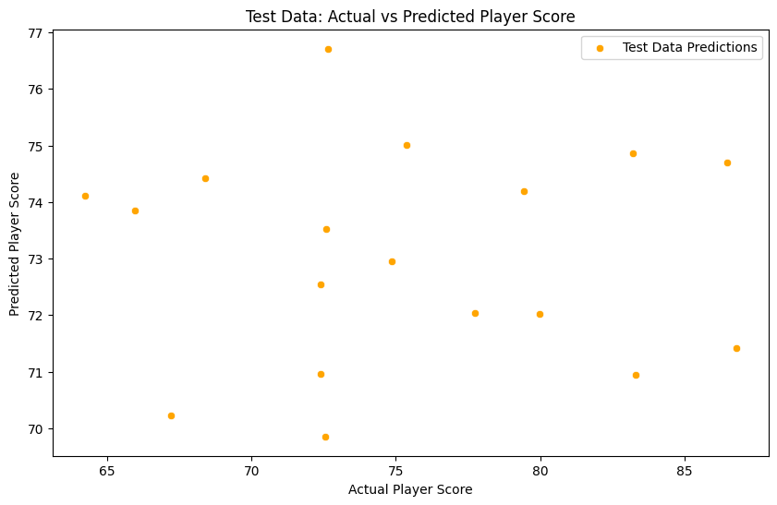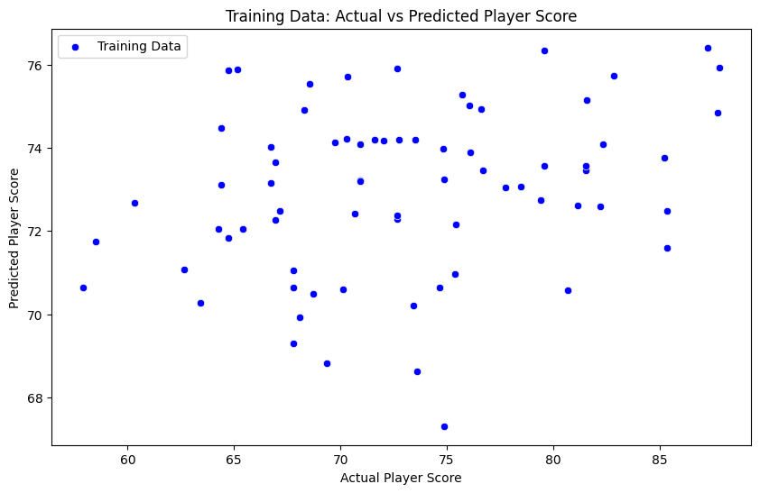

Faculty Signature: _______________ Date: _____________________